JAPAN FINANCIRAO PROJEKT OBNOVE VODOVODA U OPĆINI KRNJAK

Kroz program donacija Vlade Japana odobrena su sredstva u vrijednosti od 70,128 eura za obnovu vodovoda u općini Krnjak.
Na primopredajnoj ceremoniji koja se održala 24. listopada 2006. godine ispred obiteljske kuće blizu mjesta Krnjak, veleposlanik Japana u Republici Hrvatskoj, Nj.E. gospodin Tetsuhisa Shirakawa u prisutnosti načelnika Općine Krnjak, gospodina Rade Kosanovića, simboličnim presijecanjem vrpce službeno je pustio u uporabu obnovljeni vodovod u Krnjaku. Novi vodovod, dužine 140 m, omogućiti će brži razvoj područja i poboljšati uvjete života u tom dijelu Hrvatske.

Od 1999. godine Vlada Japana provodi program donacija na širem području Republike Hrvatske.

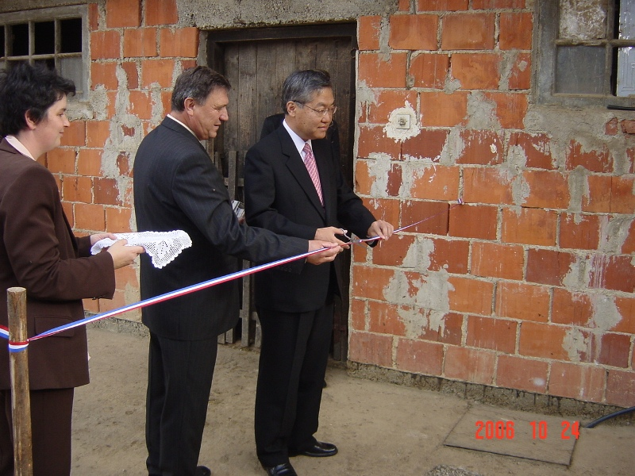 | 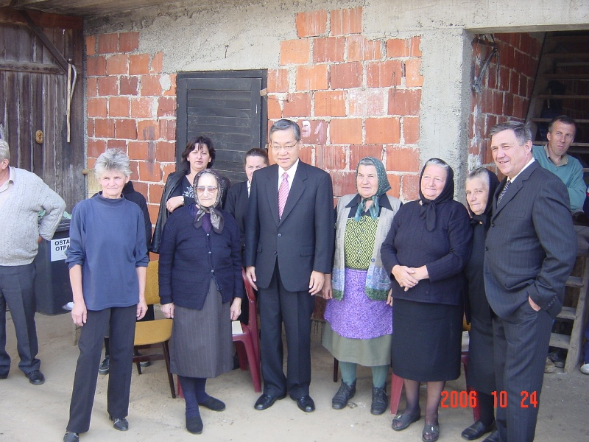
Veleposlanik Japana u prisutnosti gospodina Rade Kosanovića, načelnika Općine Krnjak, službeno je pustio u uporabu obnovljeni vodovod | Veleposlanik Japana sa stanovnicima naselja Krnjak

_____________________________________________________________________________

Japan Provides Funds for Water Supply Project in Krnjak Municipality

The Government of Japan has provided funding of 70,128 Euro under its Grass Roots Assistance Program Scheme to the Krnjak Municipality for the Project for Construction of Connection Water Supply System in Krnjak.

At the handover ceremony that was held on 24 October 2007 in front of the family house in a small village next to Krnjak, the Ambassador of Japan, H.E. Mr. Tetsuhisa Shirakawa cut the ribbon in presence of Mr. Rade Kosanović, Head of Krnjak Municipality and officially put into operation the upgraded water supply system in Krnjak. The new water supply system, 140 m in length, will enable faster development of the region and improvement of people’s living standards.

Since 1999 the Government of Japan has been implementing projects in the Republic of Croatia. The GGP program is specifically designed to address basic human needs, which include water supply, health, basic education, vocational training, sanitary environment and rural infrastructure.

